Syeda Reeha Quasar

14114802719

4C7

Aim

To find the value of a definite integral using

(a) Trapezoidal rule

(b) Simpsons 1/3 rule

(c) Simpsons 3/8 rule.

Experiment - 5

APPLIED MATHEMATICS LAB

# **EXPERIMENT – 5**

## **Aim:**

To find the value of a definite integral using

(a) Trapezoidal rule

(b) Simpsons 1/3 rule

(c) Simpsons 3/8 rule.

**Source Code:**

**Trapezoidal rule**

***// Program to find integration by using Trapezoidal rule***

clc

clear

close

printf('\n\n Name - Syeda Reeha Quasar \n Enrolment No. - 14114802719 \n Group - C7 \n\n')

deff ('y = f(x)', 'y = sin(x)')

x0 = 0

xn = %pi

n = 10

h = (xn - x0)/n

s = 0

for i = 1:n

s = s + f(x0 + (i - 1)*h) + f(x0 + i * h)

end

integral = (h * s)/2

printf('\n The value of integral is = %g \n', integral)

# **Output:**

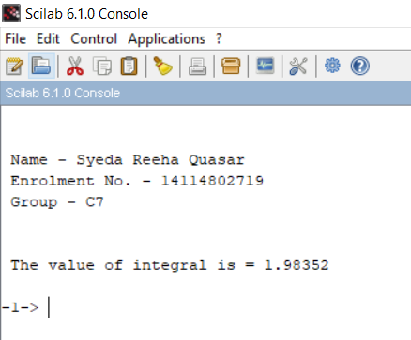

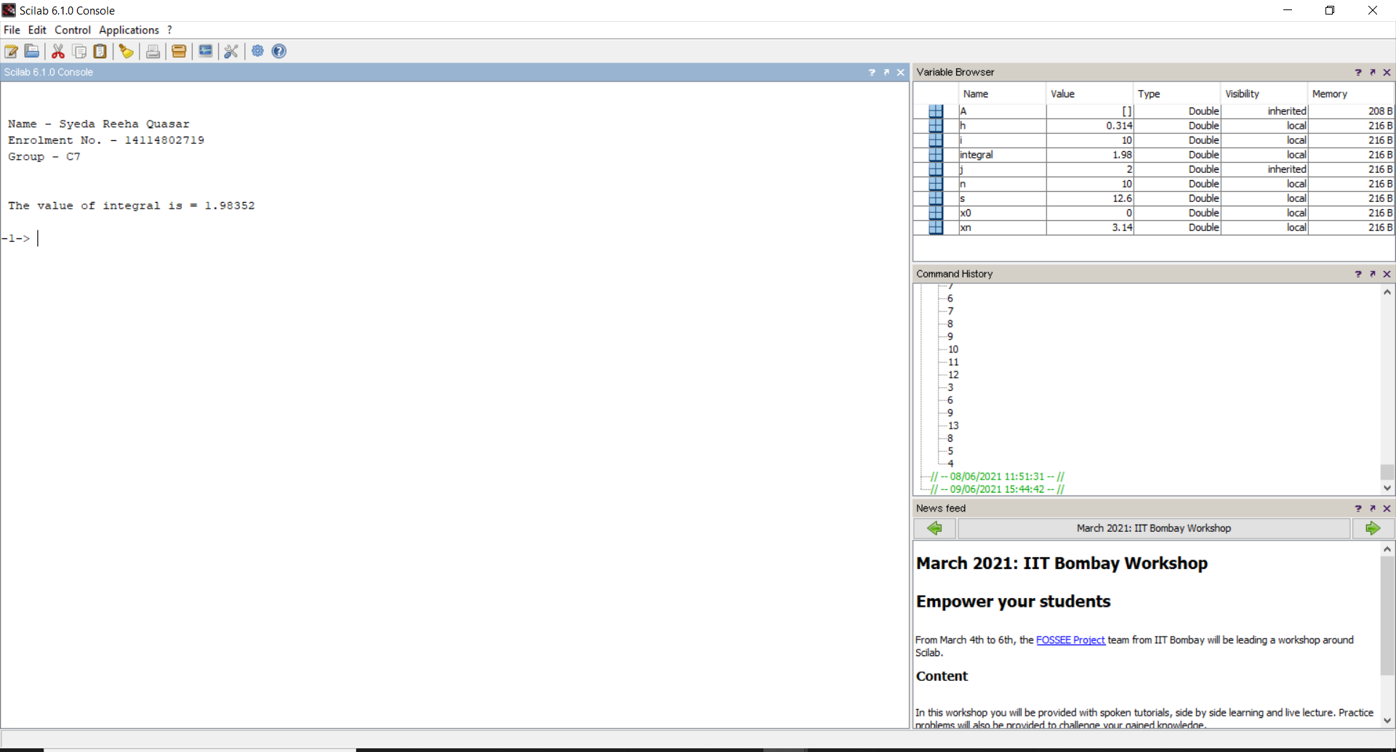

***// Program to find integration by using Trapezoidal rule***

clc

clear

close

deff ('y = f(x)', 'y = 1/(1 + x^2)')

x0 = 0

xn = 6

n = 6

h = (xn - x0)/n

s = 0

for i = 1:n

s = s + f(x0 + (i - 1)*h) + f(x0 + i * h)

end

integral = (h * s)/2

printf('\n The value of integral is = %g \n', integral)

# **Output:**

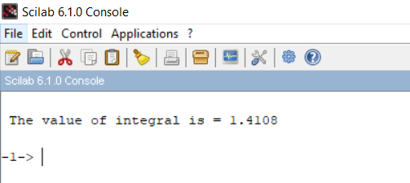

##### **Simpsons 1/3 rule**

***// Program to find integration by using Simpson's 1/3 rule***

clc

clear

close

printf('\n\n Name - Syeda Reeha Quasar \n Enrolment No. - 14114802719 \n Group - C7 \n\n')

deff ('y = f(x)', 'y = 1/(1 + x^2)')

x0 = 0

xn = 6

n = 6

h = (xn - x0)/n

s = 0

for i = 1:2:n

s = s + f(x0 + (i - 1)*h) + 4*f(x0 + i * h) + f(x0 + (i+1) * h)

end

integral = (h * s)/3

printf('\n The value of integral is = %g \n', integral)

# **Output:**

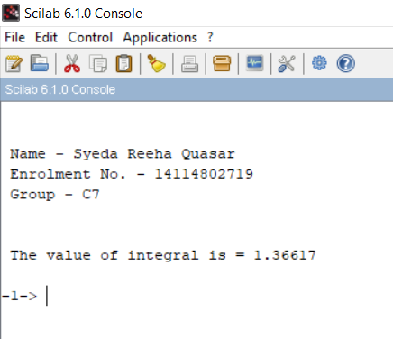

*// Program to find integration by using Simpson's 1/3 rule*

clc

clear

close

deff ('y = f(x)', 'y = sin(x)')

x0 = 0

xn = %pi

n = 10

h = (xn - x0)/n

s = 0

for i = 1:2:n

s = s + f(x0 + (i - 1)*h) + 4*f(x0 + i * h) + f(x0 + (i+1) * h)

end

integral = (h * s)/3

printf('\n The value of integral is = %g \n', integral)

# **Output:**

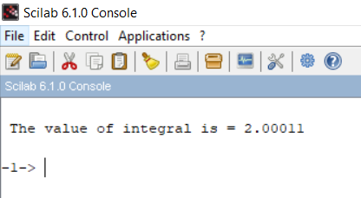

##### **Simpsons 3/8 rule**

***// Program to find integration by using Simpson's 3/8 rule***

clc

clear

close

printf('\n\n Name - Syeda Reeha Quasar \n Enrolment No. - 14114802719 \n Group - C7 \n\n')

deff ('y = f(x)', 'y = 1/(1 + x^2)')

x0 = 0

xn = 6

n = 6

h = (xn - x0)/n

s = 0

for i = 1:3:n

s = s + f(x0 + (i - 1)*h) + 3*f(x0 + i * h) + 3 * f(x0 + (i+1) * h) + f(x0 + (i+2) * h)

end

integral = (3 * h * s)/8

printf('\n The value of integral is = %g \n', integral)

# **Output:**

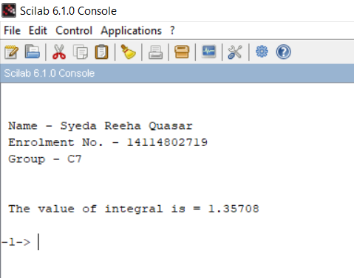

***// Program to find integration by using Simpson's 3/8 rule***

clc

clear

close

deff ('y = f(x)', 'y = sin(x)')

x0 = 0

xn = %pi

n = 6

h = (xn - x0)/n

s = 0

for i = 1:3:n

s = s + f(x0 + (i - 1)*h) + 3*f(x0 + i * h) + 3 * f(x0 + (i+1) * h) + f(x0 + (i+2) * h)

end

integral = (3 * h * s)/8

printf('\n The value of integral is = %g \n', integral)

# **Output:**

